1. General information

There is 3-axis accelerometer sensor LIS3L02AL of ST Microelectronics inside the Wii-Nunchuk. It includes a 10-bit A/D converter, an analog joystick and 2-button switches. The figure 1 shows the components of Wii-Nunchuk and connectors pin assignment.

C button
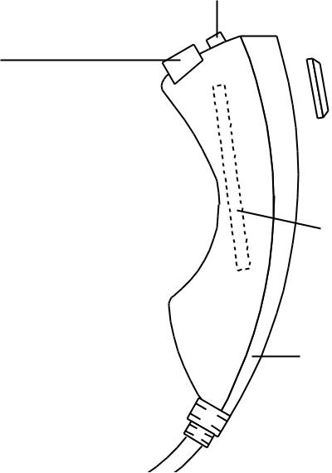

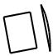
Analog joystick

Z button

3-axis accelerometer sensor is installed in right-angle axis with joystick

Handheld

Nunchuk component

+3.3V
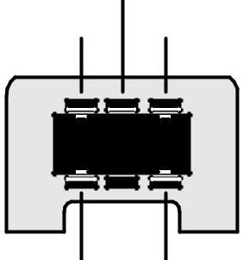
SDA N/C

GND SCL

Pin assignment of Nunchuk connector. See from front view.

2. Accelerometers directions

Center position

Read data about 512
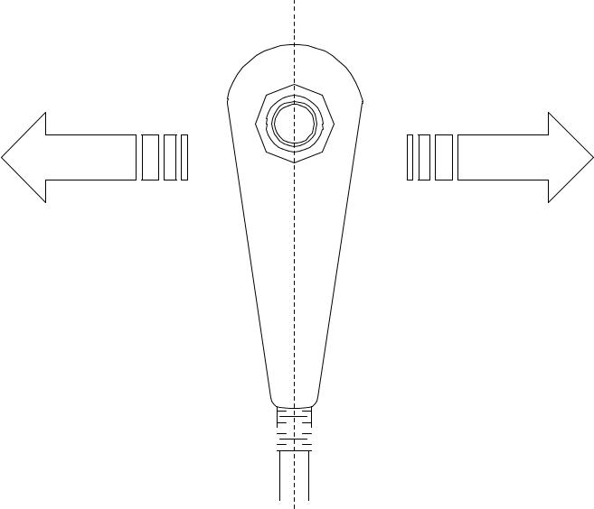

Swing to left direction

Slow : X-axis acceleration is less deviation. Fast : X-axis acceleration value reduce fast.
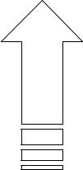

Move forward direction

Slow : Y-axis acceleration is less deviation. Fast : Y-axis acceleration value increase fast.
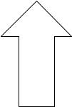

Swing to right direction

Slow : X-axis acceleration is less deviation. Fast : X-axis acceleration value increase fast.
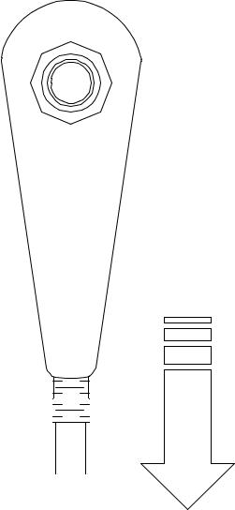

Center position

Read data about 512

Move backward direction

Slow : Y-axis acceleration is less deviation. Fast : Y-axis acceleration value reduce fast.

Lift-up direction

Slow : Z-axis acceleration is less deviation. Fast : Z-axis acceleration value increase fast.

Center position
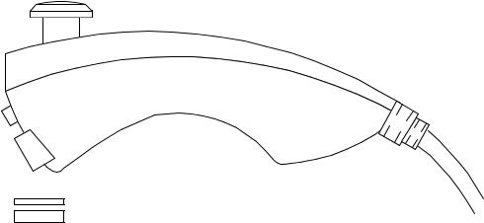
Read data about 512

Lift-down direction
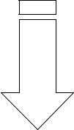
Slow : Z-axis acceleration is less deviation. Fast : Z-axis acceleration value reduce fast.

Figure 2 : Wii-Nunchuk physical operation

3. Protocol

Wii-Nunchuck is a slave I²C bus device. Its preprogrammed Id (Address) is 0x52.

1 | 0 | 1 | 0 | 0 | 1 | 0 | R/W

The reading data of the Wii-Nunchuk consists of 6 bytes data. The summary of exact data after decoding can show as follows :

 |  |  | Data byte receive |  |  |  |  | Address
 |  |  | Joystick X |  |  |  |  | 0x00
 |  |  |  |  |  |  |  | 0x01
 |  |  | Joystick Y |  |  |  |  | 0x01
 |  |  |  |  |  |  |  | 0x02
 | Accelerometer X (bit 9 to bit 2 for 10-bit resolution) |  |  |  |  |  |  | 0x02
 |  |  |  |  |  |  |  | 0x03
 | Accelerometer Y (bit 9 to bit 2 for 10-bit resolution) |  |  |  |  |  |  | 0x03
 |  |  |  |  |  |  |  | 0x04
 | Accelerometer Z (bit 9 to bit 2 for 10-bit resolution) |  |  |  |  |  |  | 0x04
Accel. Z | Accel. Z | Accel. Y | Accel. Y | Accel. X | Accel. X | C-button | Z-button | 0x05
bit 1 | bit 0 | bit 1 | bit 0 | bit 1 | bit 0

Byte 0x00 : X-axis data of the joystick Byte 0x01 : Y-axis data of the joystick

Byte 0x02 : X-axis data of the accellerometer sensor
Byte 0x03 : Y-axis data of the accellerometer sensor
Byte 0x04 : Z-axis data of the accellerometer sensor
Byte 0x05 : bit 0 as Z button status - 0 = pressed and 1 = release
bit 1 as C button status - 0 = pressed and 1 = release

bit 2 and 3 as 2 lower bit of X-axis data of the accelerometer sensor
bit 4 and 5 as 2 lower bit of Y-axis data of the accelerometer sensor
bit 6 and 7 as 2 lower bit of Z-axis data of the accelerometer sensor

4. Programming

4.1 Initialize start Nunchuk command

Set the Nunchuk as ready after power-on. Write the command 0xF0 and 0x55 follows the slave ID byte 0x52 + R/W = 0 . Normally this command is written at once.

START | 0x52 | R/W=0 | Slave | 0xF0 | Slave | 0x55 | Slave | STOP
 |  |  | Ack. |  | Ack. |  | Ack.

4.2 Conversion command (0x00)

Send this command to get all sensor data and store into the 6-byte register within Nunchuk controller. This must be execute before reading data from the Nunchuk.

START | 0x52 | R/W=0 | Slave | 0x00 | Slave | STOP
 |  |  | Ack. |  | Ack.

4.3 Data read command

Send the slave ID for reading (0x52) and wait for the stream data 6-byte from the Nunchuk.

START | 0x52 | R/W=1 | Slave | Byte1 | Master | Byte2 | Master | Byte3 | Master
 |  |  | Ack. |  | Ack. |  | Ack. |  | Ack.
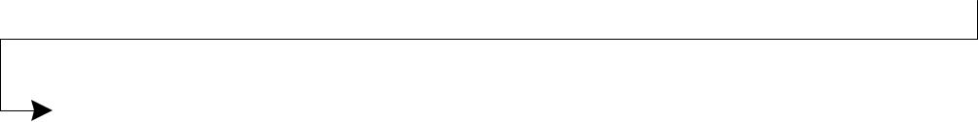

Byte4 | Master | Byte5 | Master | Byte6 | Master | STOP
 | Ack. |  | Ack. |  | no
 |  |  |  |  | Ack.

