LYCEE HENRI BRISSON
DATASETS
Rendu images (élèves)
Gregoire BURNET

Regroupement de l’ensemble des images traités sous le logiciels Adobe Photoshop

Sommaire
M82 3
Edu008 : The Eagle Nebula 4
Edu010 : The Star Forming Nebula - Messier 17 5
Edu011 : The Proto Planetary Nebula - Roberts 22 6
Edu012 : The Planetary Nebula NGC 5307 7
Edu013 : The Planetary Nebula NGC 6309 - Box Nebula 8
Edu014 : The Planetary nebula NGC 6881 9
Edu015 : UltraViolet Venus 10
Edu016 : The Galaxy NGC 1068 11
Edu017 : The star-forming region N11B 12
Edu018 : The Planetary Nebula NGC 6302 - Bug Nebula 13
Edu019 : The Dwarf Galaxy NGC 1569 14
Edu020 : The Globular Cluster Messier 12 15
Edu021 : The Globular Cluster NGC 6652 16
Edu022 : The Galaxy Messier 31 17
Edu023 : The Open Cluster Messier 35 18
Edu024 : The Orion Nebula Messier 42 19
Edu025 : The colliding Antennae Galaxies 20
Edu027 : Messier 106 21

M82
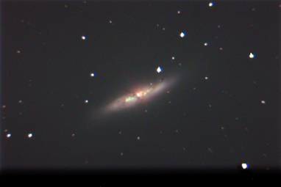

Edu008 : The Eagle Nebula
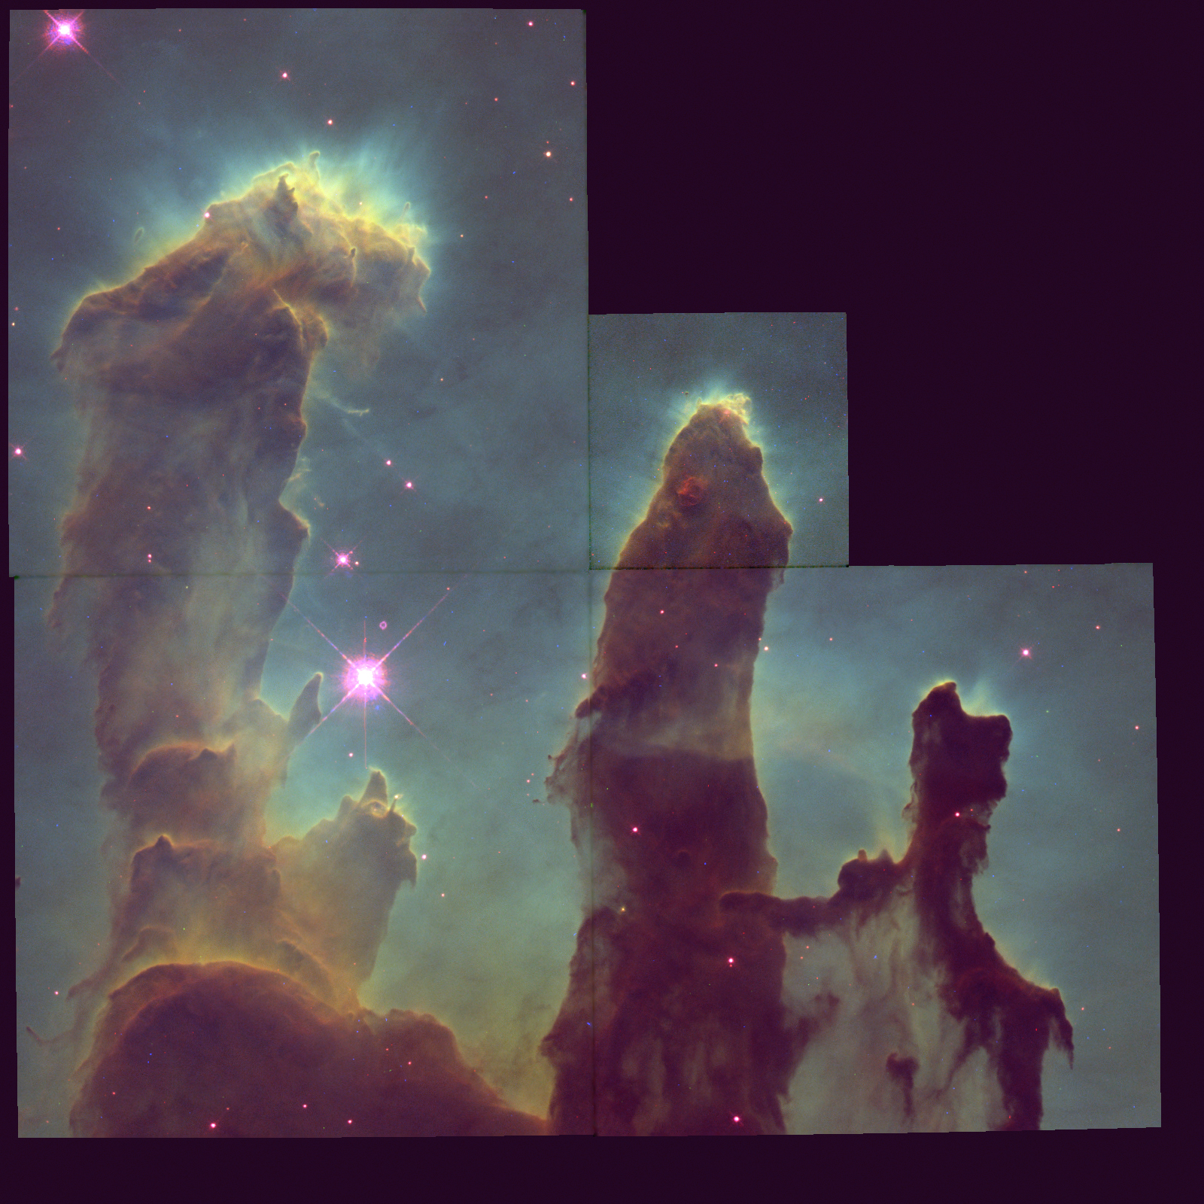

Edu010 : The Star Forming Nebula - Messier 17
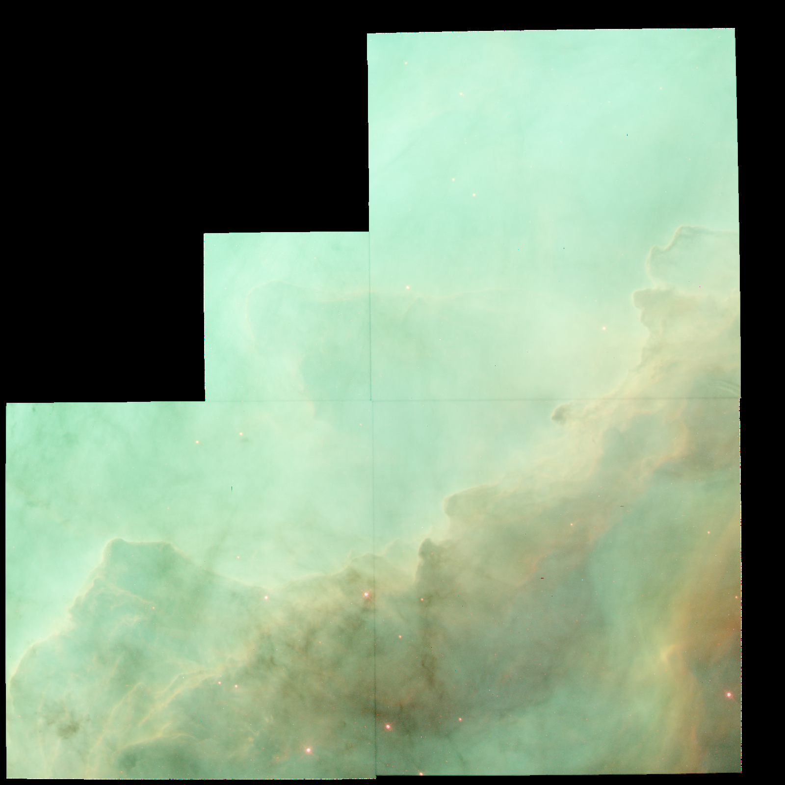

Edu011 : The Proto Planetary Nebula - Roberts 22
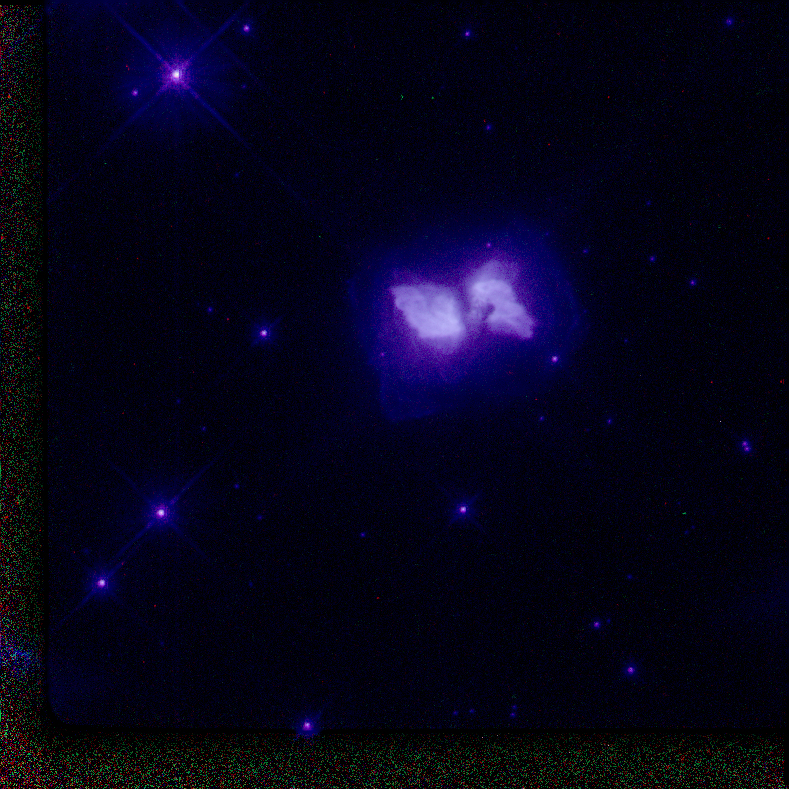

Edu012 : The Planetary Nebula NGC 5307
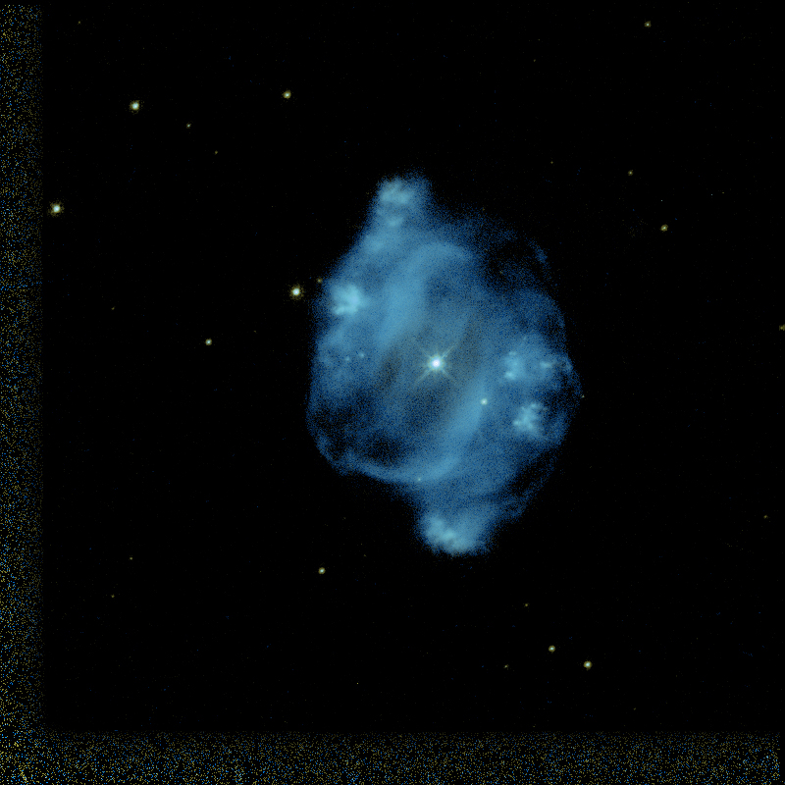

Edu013 : The Planetary Nebula NGC 6309 - Box Nebula
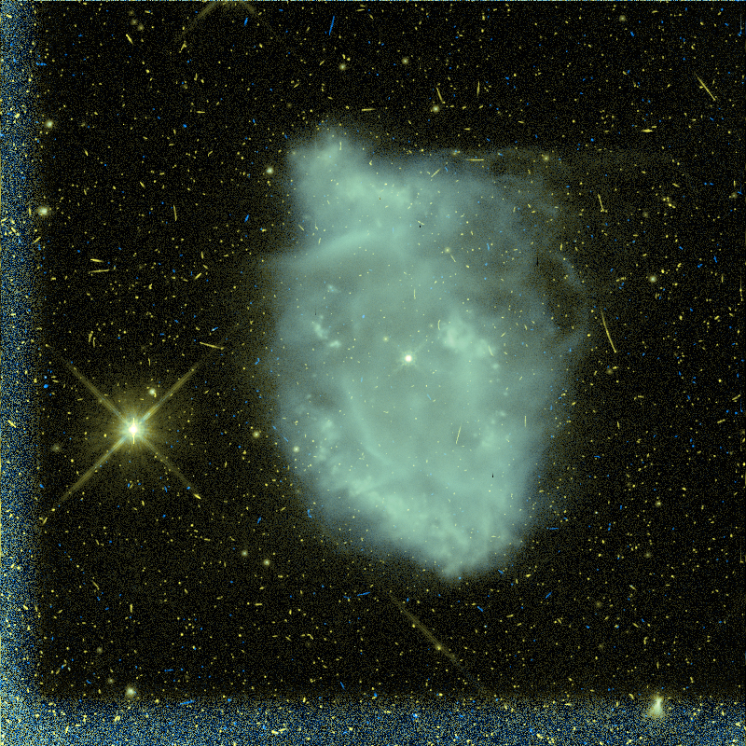

Edu014 : The Planetary nebula NGC 6881
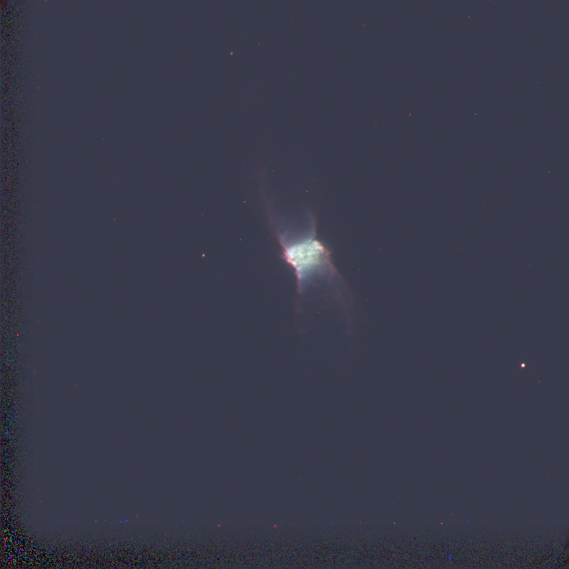

Edu015 : UltraViolet Venus
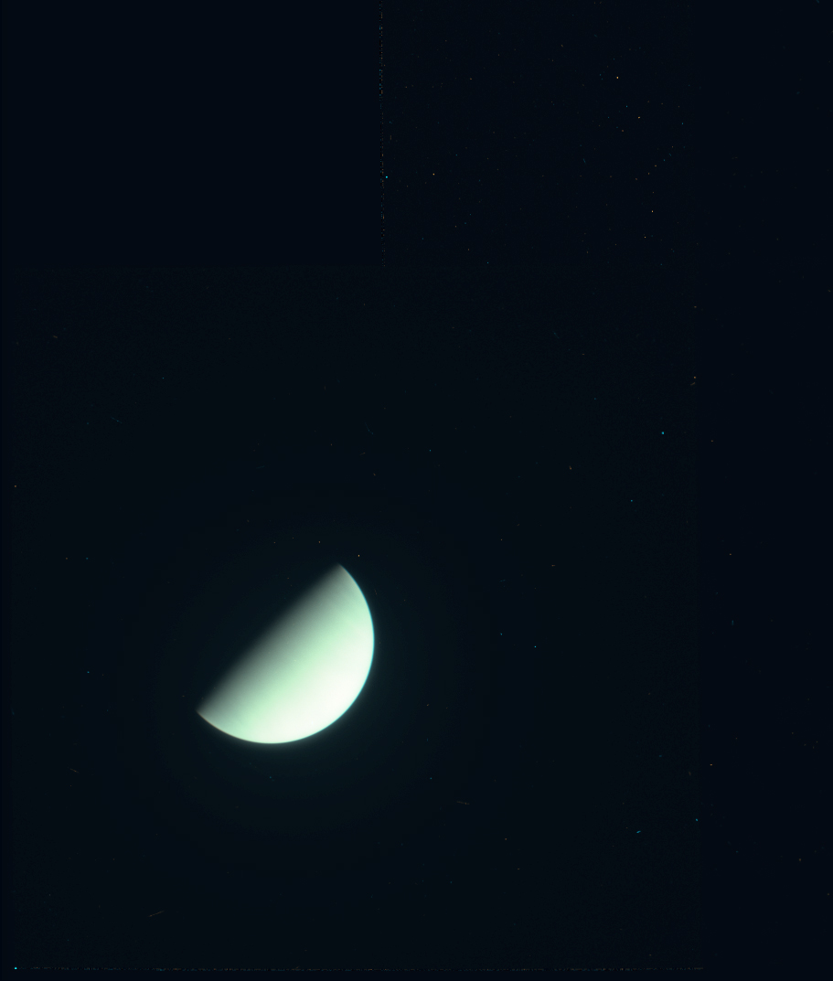

Edu016 : The Galaxy NGC 1068
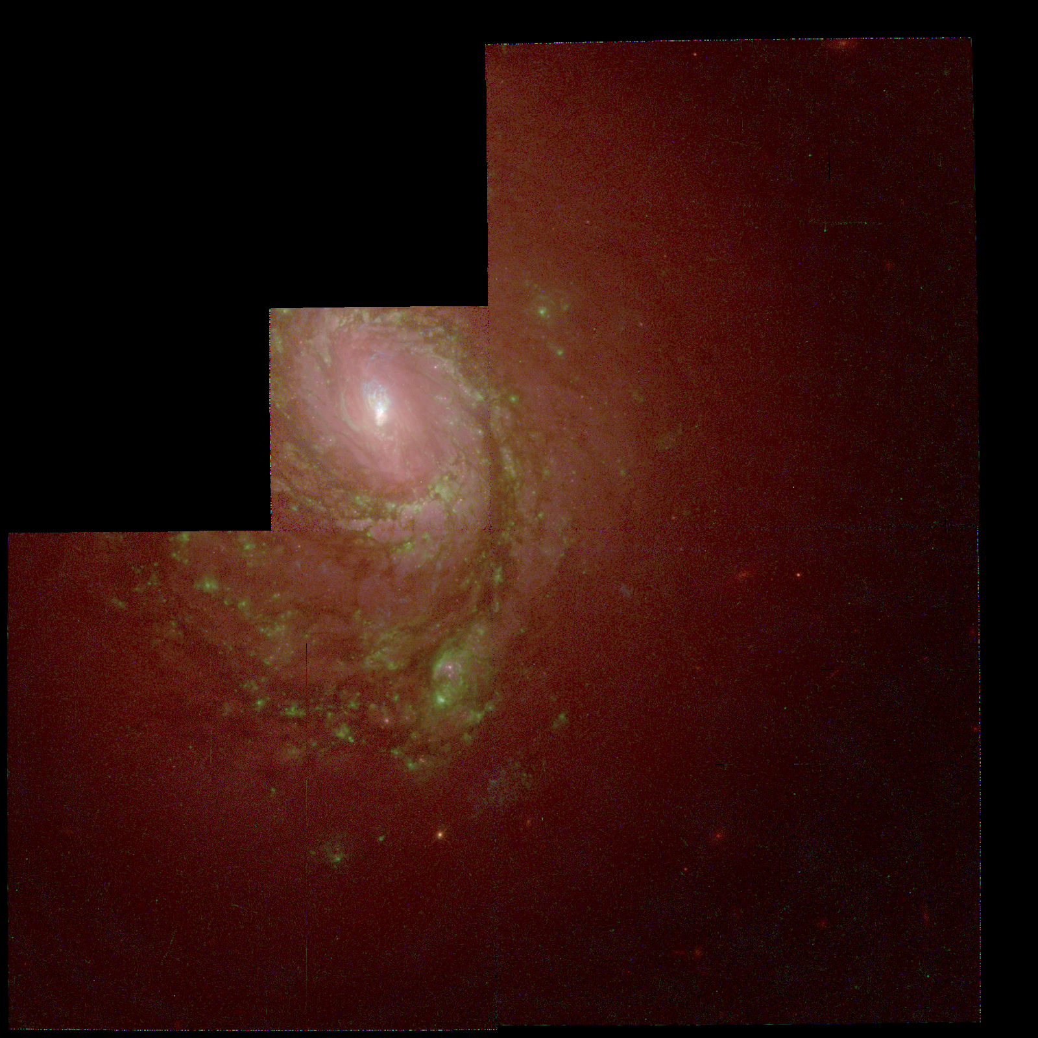

Edu017 : The star-forming region N11B
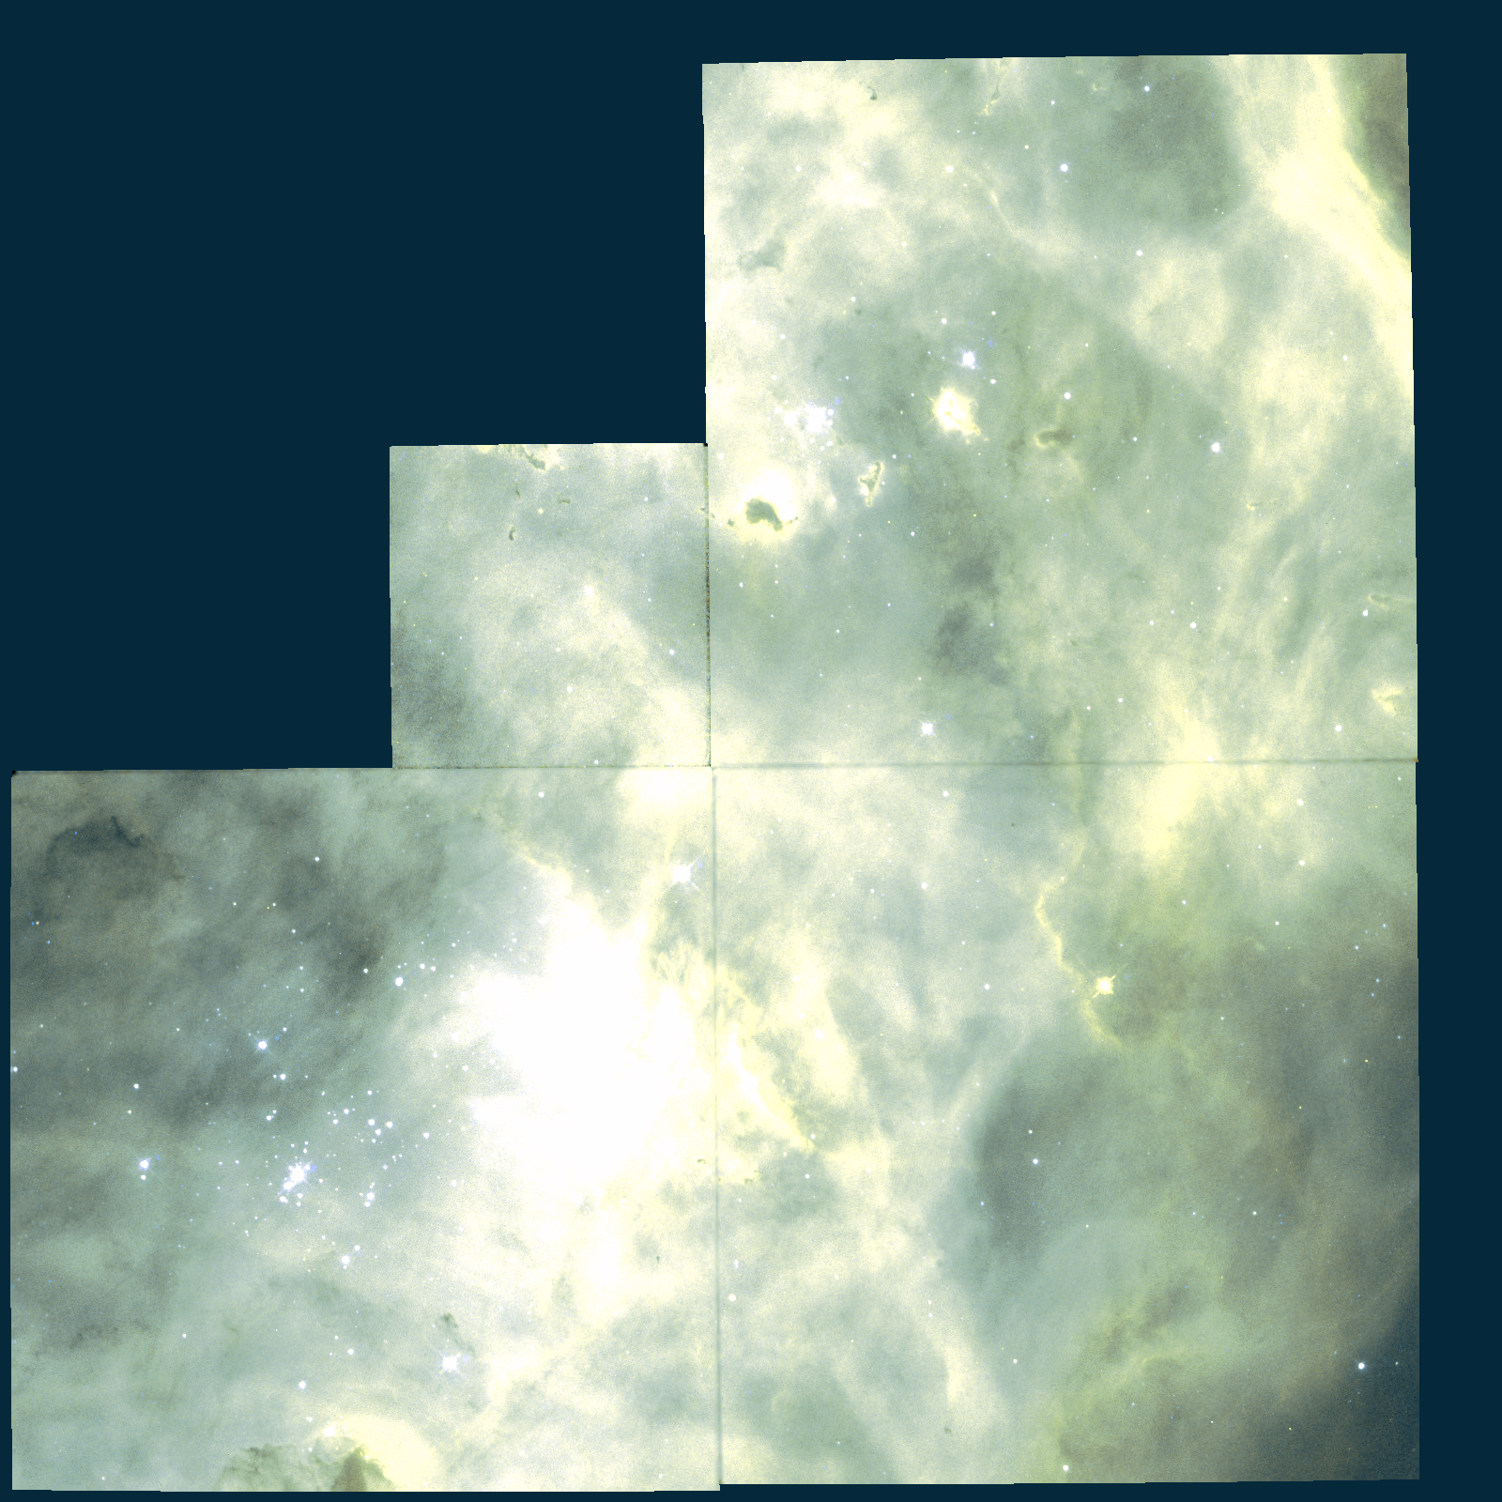

Edu018 : The Planetary Nebula NGC 6302 - Bug Nebula
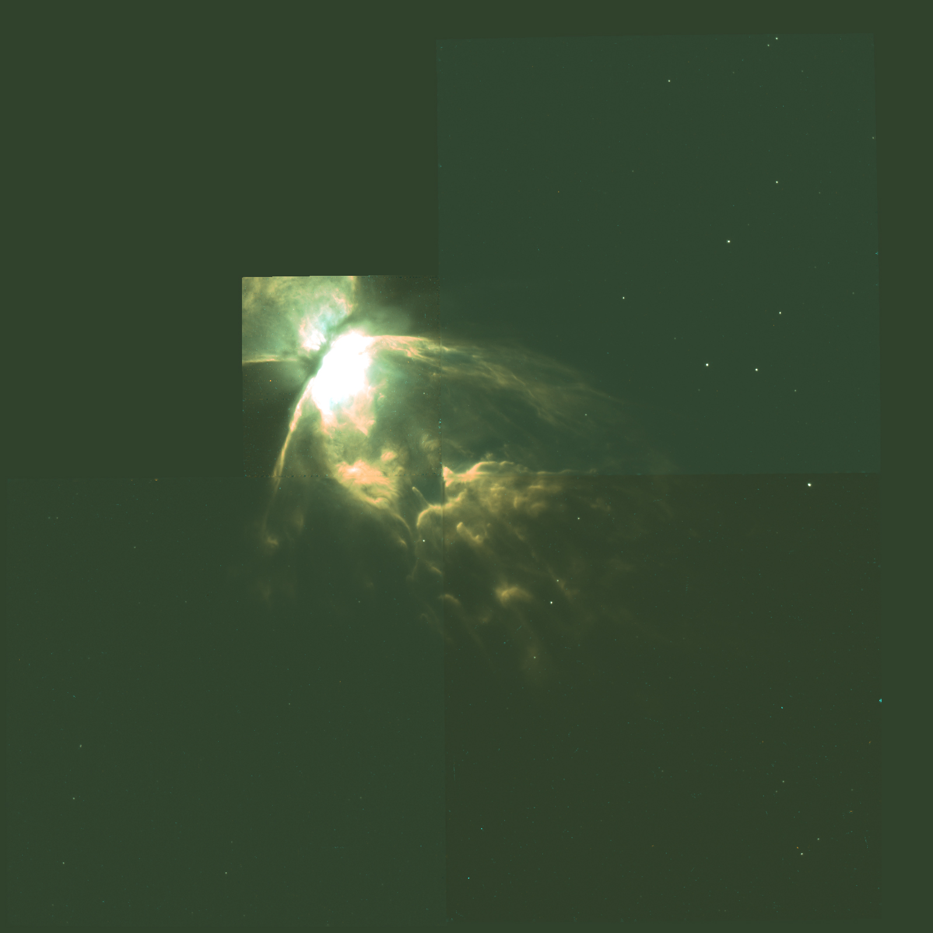

Edu019 : The Dwarf Galaxy NGC 1569
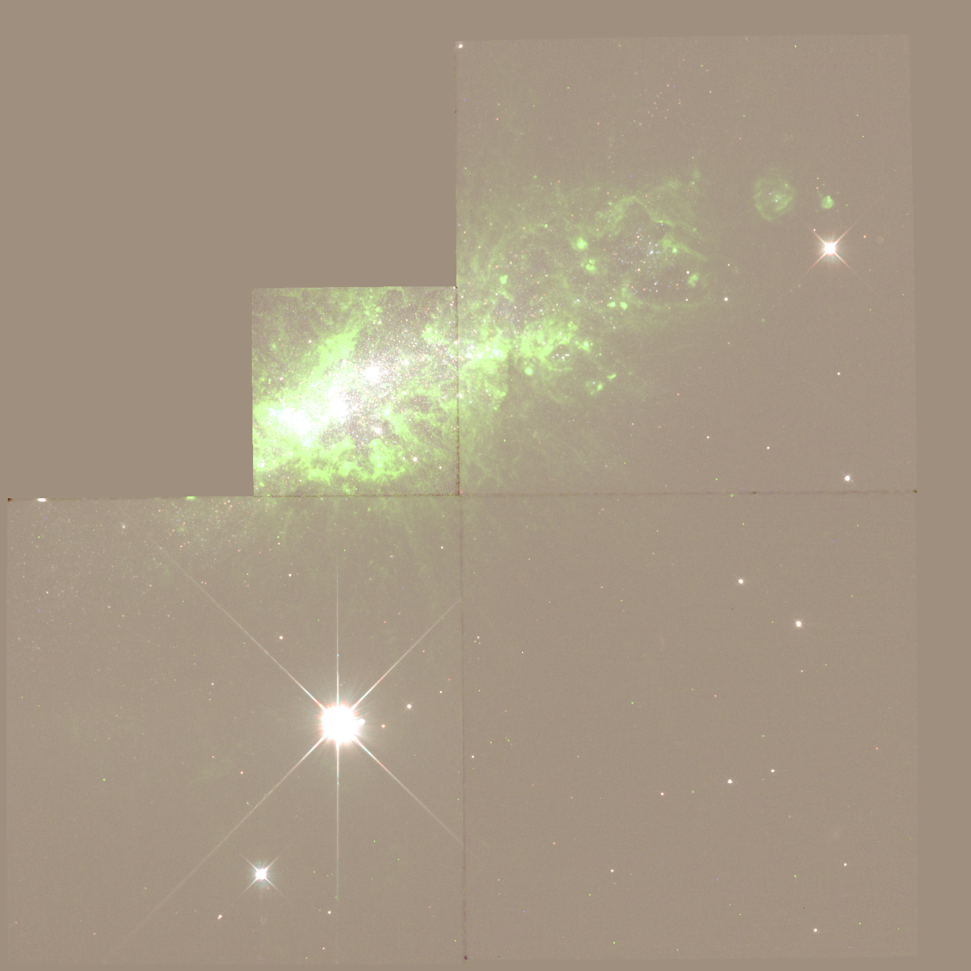

Edu020 : The Globular Cluster Messier 12
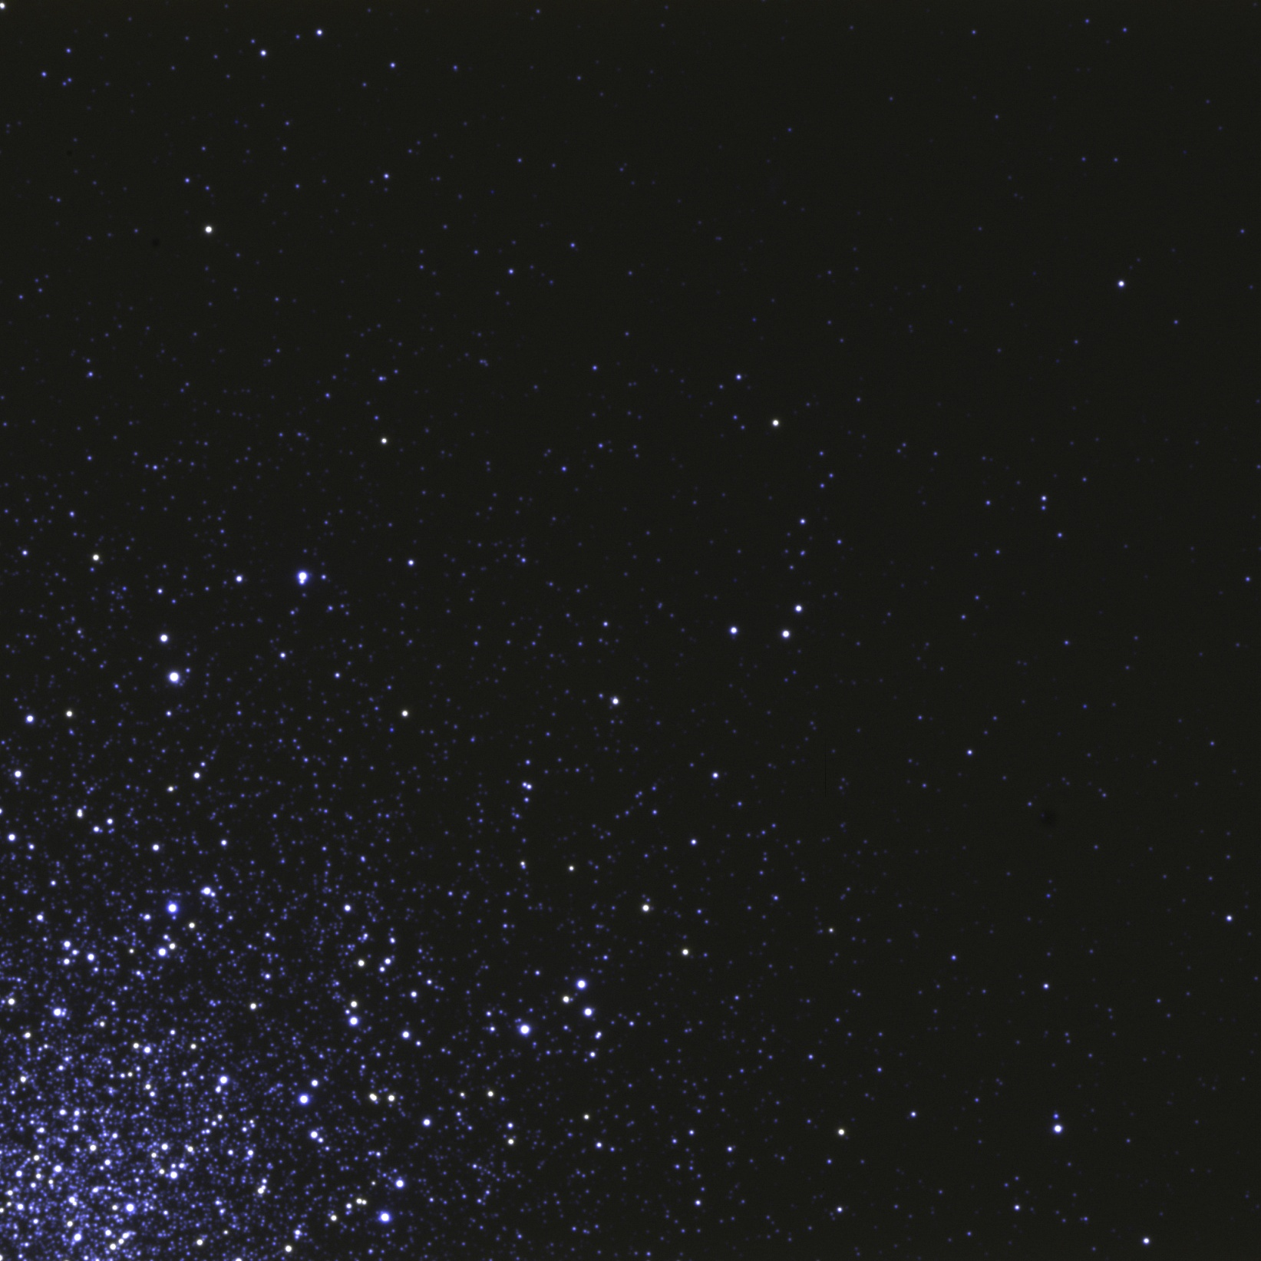

Edu021 : The Globular Cluster NGC 6652
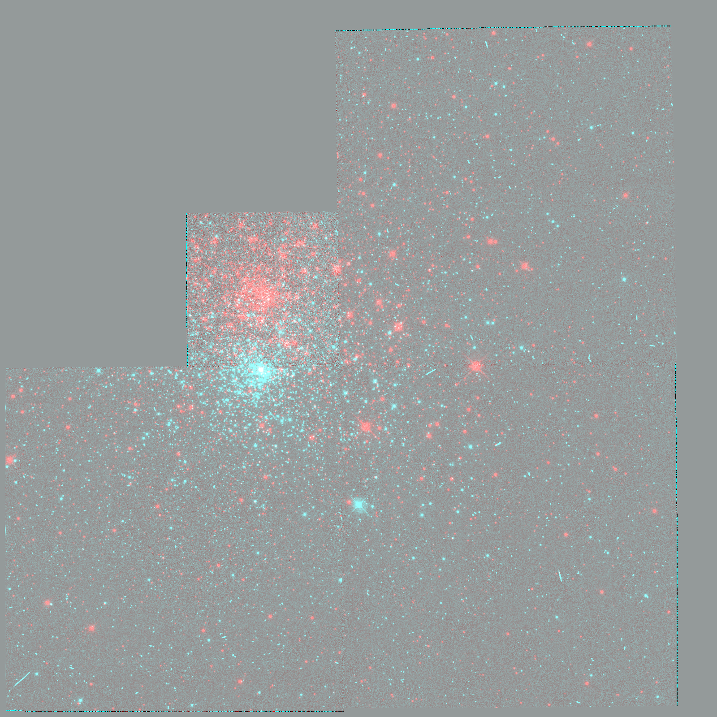

Edu022 : The Galaxy Messier 31
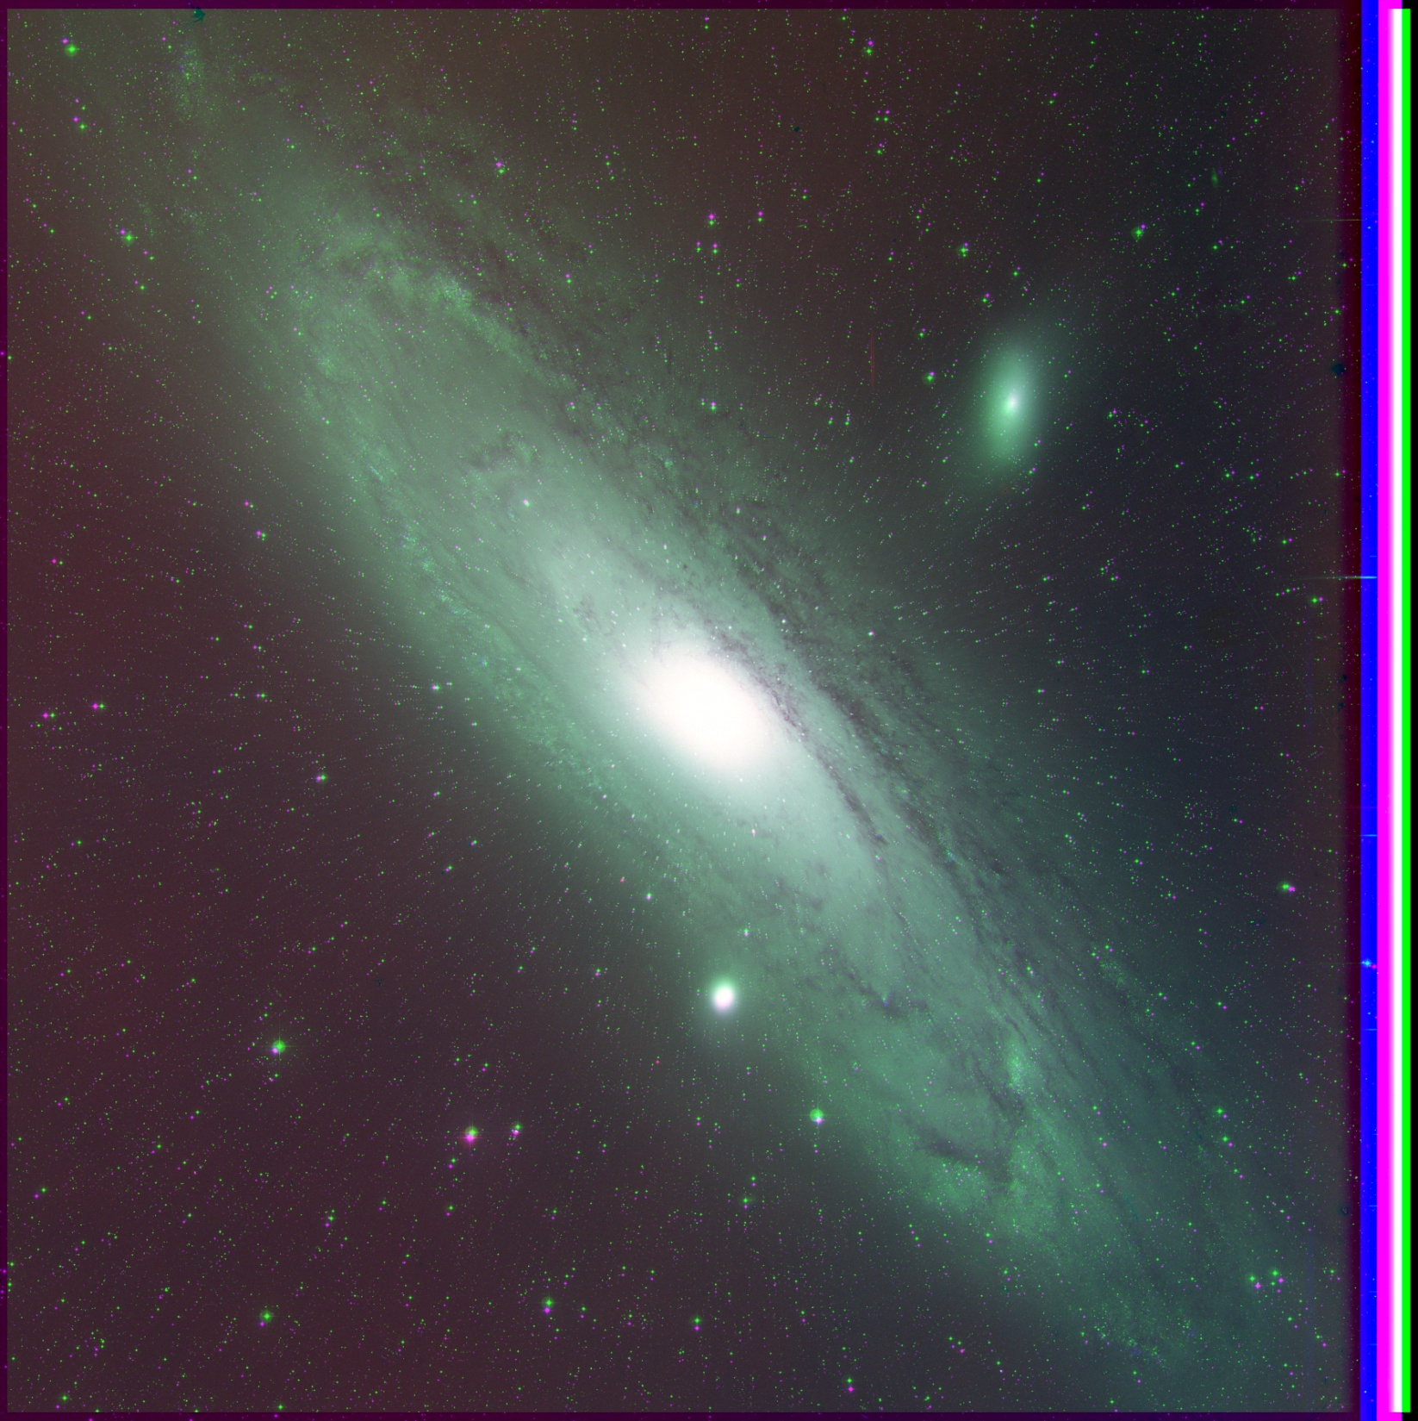

Edu023 : The Open Cluster Messier 35
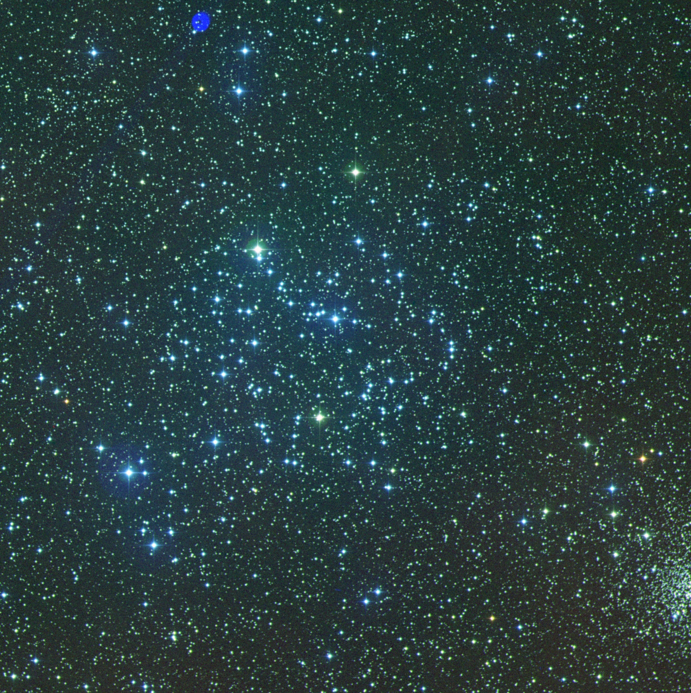

Edu024 : The Orion Nebula Messier 42
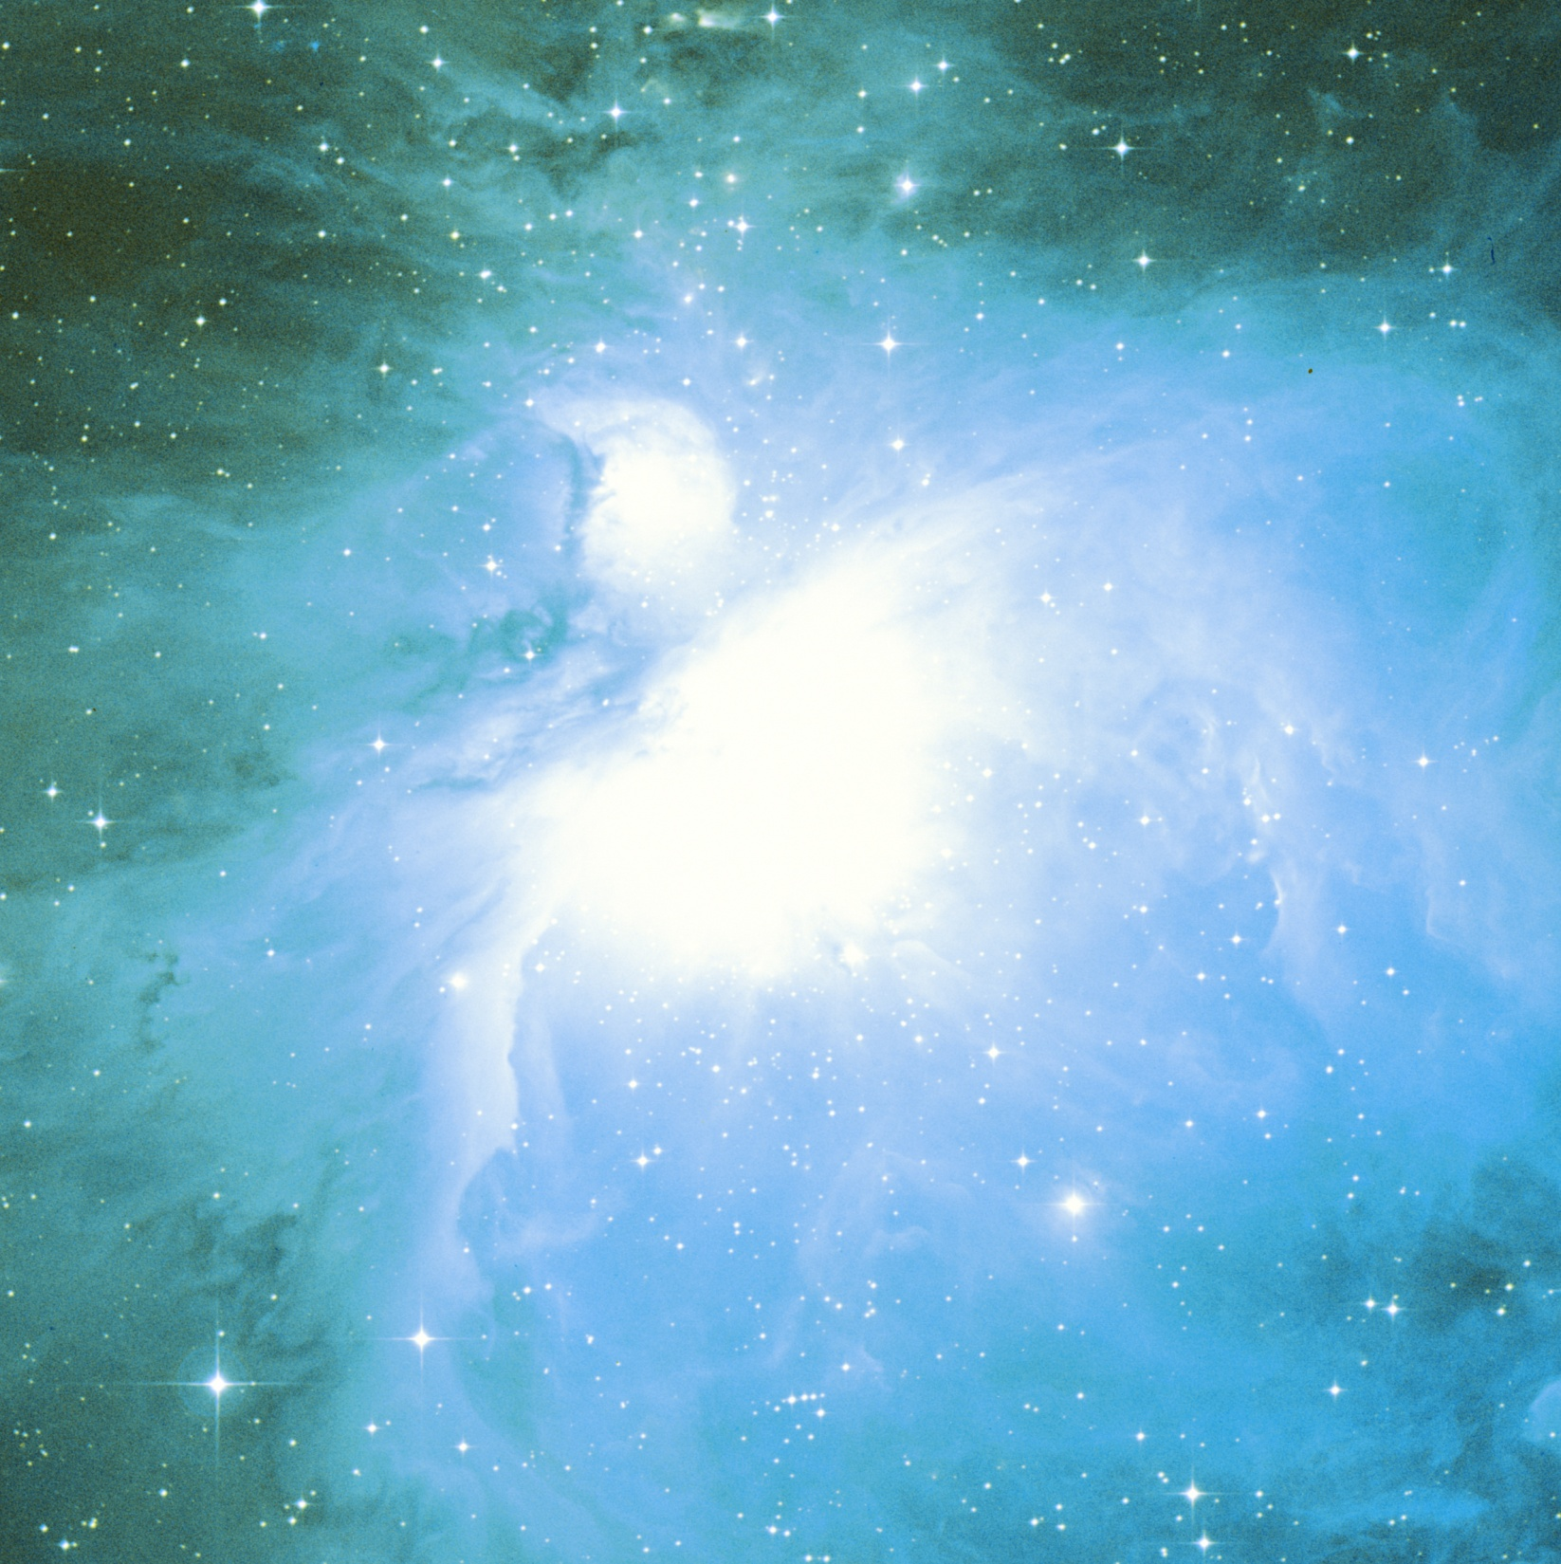

Edu025 : The colliding Antennae Galaxies
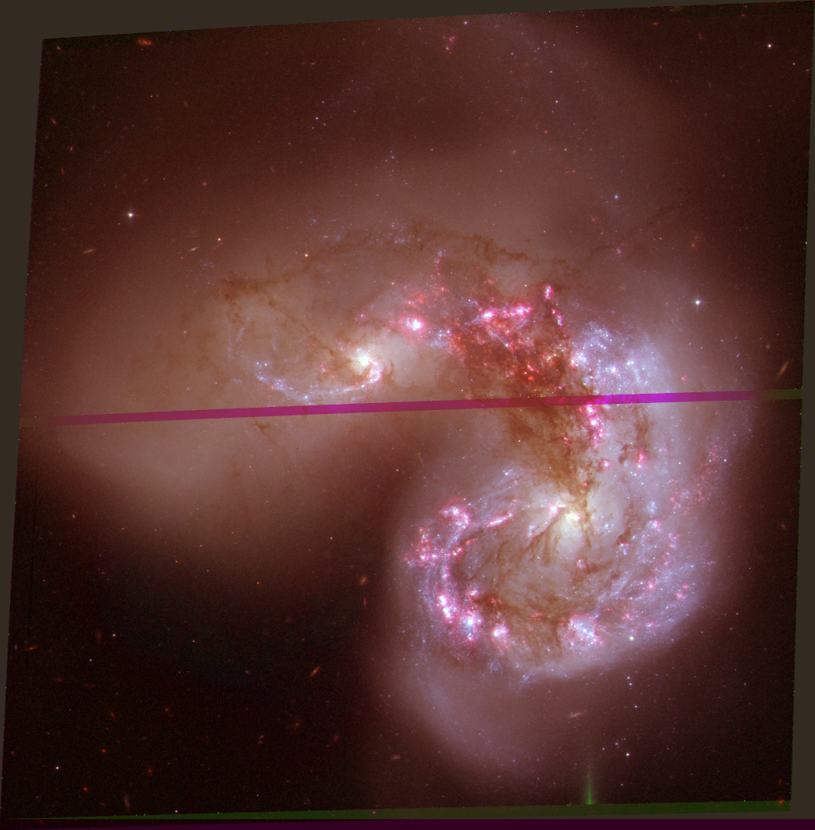

Edu027 : Messier 106
